Information Leaflet - Hiatus Hernia
What is Hiatus Hernia?
A hiatus hernia is where part of the stomach pushes up into the lower chest through a defect in the diaphragm. The diaphragm is the large flat muscle that separates the lungs from the abdomen that helps us to breathe. Most people with a hiatus hernia do not have any symptoms or problems. However, the hernia makes you more prone to reflux acid into your oesophagus (gullet) which can cause heartburn and other symptoms. If symptoms do occur, treatment with acid-suppressing medication usually works well.

Understanding the upper gut
The gut or 'gastrointestinal tract' is the tube that starts at the mouth and ends at the anus.
The upper gut includes the oesophagus (gullet), stomach and duodenum. Food passes down the oesophagus into the stomach. The stomach makes acid, which is not essential, but helps to digest food. After being mixed in the stomach, food passes into the duodenum (the first part of the small intestine) to be digested.
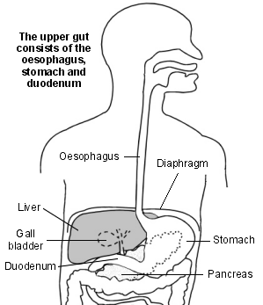
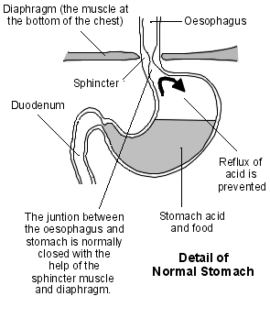
The walls of the stomach contain muscle. At the junction of the stomach and the oesophagus there is a thickened area of muscle which is called a sphincter. The sphincter acts like a valve. When food comes down the oesophagus into the stomach, the sphincter relaxes. However, it closes at other times to stop food and acid in the stomach refluxing back into the oesophagus.
The diaphragm is a large flat muscle that separates the lungs from the abdomen. It helps us to breathe. The oesophagus comes through a hole ('hiatus') in the diaphragm just before it joins to the stomach. Normally, all the stomach is below the diaphragm. The muscle fibres in the diaphragm around the lower oesophagus help the sphincter to keep the oesophagus closed to prevent reflux of acid and food.

What is a hernia?
A hernia is when part of an organ protrudes (pushes) through a muscular wall that holds it in place. There are different types of hernia. For example, an inguinal hernia is the most common type when part of the lower bowel protrudes through the muscle in the groin. A hiatus hernia is when part of the stomach protrudes through the diaphragm.

What are the types of hiatus hernia?
Sliding hiatus hernia - is the most common type. In this situation the sphincter at the bottom of the oesophagus and the top of the stomach protrudes through the hole (hiatus) in the diaphragm. The hernia may slide up and down, in and out of the lower chest. It is often quite small.
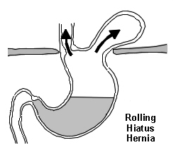
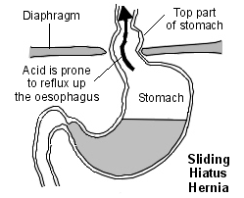
Rolling hiatus hernia - is less common. In this situation, part of the stomach protrudes up through the hole in the diaphragm next to the oesophagus.

What causes hiatus hernia and how common is it?
The exact number of people with a hiatus hernia is not known as many people with a hiatus hernia do not have symptoms. However, they are thought to be common. Some studies suggest that up to a third of people develop a hiatus hernia sometime in their life, most commonly in middle age. Many are small.
The cause of hiatus hernia is not clear. It is thought that most develop in people over the age of 50. It may be that the diaphragm weakens with age and allows part of the stomach to protrude through the hole in the diaphragm. Factors which increase the pressure in the abdomen such as regular coughing, weightlifting or obesity may increase the risk of developing a hiatus hernia.
(There is a rare type of hiatus hernia which occurs in newborn babies due to a congenital defect of the stomach or diaphragm. This is not dealt with further in this leaflet.)

What are the symptoms of hiatus hernia?

Often there are none - Many people with a hiatus hernia have no symptoms.
Acid reflux symptoms - The hernia itself does not cause symptoms. However, if you have a hiatus hernia, the factors that normally prevent stomach acid from refluxing into the oesophagus may not work so well. The sphincter may not work properly, and the normal pressure of the diaphragm on the oesophagus is lost. Therefore, you are more prone for acid in the stomach to reflux (regurgitate) into your oesophagus. The refluxed acid can cause inflammation of the lower part of the oesophagus which can cause one or more of the following symptoms:
- Heartburn is the main symptom. This is a burning feeling which rises from the upper abdomen or lower chest up towards the neck. (It is confusing as it has nothing to do with the heart!)

- Other common symptoms include pain in the upper abdomen and chest, feeling sick, an acid taste in the mouth, bloating, belching, and a burning pain when you swallow hot drinks. Like heartburn, these symptoms tend to come and go, and tend to be worse after a meal.
- Some uncommon symptoms may occur. If any of these symptoms occur it can make the diagnosis difficult as these symptoms can mimic other conditions. For example:
  - A persistent cough, particularly at night, sometimes occurs. This is due to the refluxed acid irritating the trachea (windpipe). Asthma symptoms of cough and wheeze can sometimes be due to acid reflux.
  - Other mouth and throat symptoms sometimes occur such as gum problems, bad breath, sore throat, hoarseness and a feeling of a lump in the throat.
  - Severe chest pain develops in some cases (and may be mistaken for a heart attack).
Note: most people with acid reflux do not have a hiatus hernia. Also, most people with a hiatus hernia do not have symptoms of acid reflux. (If you have a hiatus hernia it does not necessarily mean that the sphincter between the oesophagus and stomach does not work so well. It is just that having a hiatus hernia makes you more prone to have a poorly functioning sphincter and more prone to develop acid reflux symptoms).
However, people with a hiatus hernia who do get reflux, on average, tend to get more severe symptoms and problems associated with acid reflux. This may be because with a hiatus hernia, any acid that gets into the oesophagus is more likely to remain in contact with the lining of the oesophagus for longer compared to people without a hiatus hernia.
See separate leaflet called 'Acid Reflux and Oesophagitis' for more details.

How is a hiatus hernia diagnosed?
A hiatus hernia may be diagnosed if you have tests for symptoms of reflux. Endoscopy is the common test. This is where a thin, flexible telescope is passed down the oesophagus into the stomach. This allows a doctor or nurse to look inside. A hiatus hernia may be seen. A CT or MRI scan will detect a hiatus hernia as will special X-ray test called a barium swallow.

What is the treatment of hiatus hernia?
- If you have no symptoms, you do not need any treatment. The hiatus hernia itself causes no harm.
- If you have reflux symptoms, then treatment is the same as for any other cause of reflux symptoms. Treatment includes lifestyle factors such as losing weight if you are overweight, antacids and acid-suppressing drugs. See the leaflet called 'Acid Reflux and Oesophagitis' for details of treatment.
- Rarely, a hiatus hernia causes severe symptoms of reflux which are not helped so well with medication. Therefore, an operation is occasionally advised. During this operation the stomach is put back into the correct position, and the weakened diaphragm around the lower oesophagus is tightened.

Further Help and information
GUTS UK (formerly CORE)
2 St Andrews Place, LONDON NW1 4LB Tel: 0300 102 4887 gutscharity.org.uk

